Business Requirements Document(BRD) Template
Project/Initiative
Month 20YY
Version X.XX

Company Information

Document Revisions
Date | Version Number | Document Changes
05/02/20xx | 0.1 | Initial Draft

Approvals
Role | Name | Title | Signature | Date
Users
Business Owner

Introduction

Project Summary

Objectives
Increase booking conversion by displaying personalized hotel recommendations and marketing labels and improve the hotel search experience by providing fast, accurate, and user-friendly search functionality

Background
TravelMate is developing an enhanced hotel search functionality to improve the user experience and support business growth. Users Survey identified the need for a faster and more convenient search process with advanced filtering options, accurate hotel information, and map-based search results. The business aims to increase booking conversion, provide personalized hotel recommendations, collect user behavior analytics, and support multiple languages and currencies

Business Drivers
The development of this feature is driven by several business needs:
- Maximizing search-to-booking conversion
- Ensuring up-to-date information on room availability in real time
- Collecting analytics on the use of filters for business decision-making and hotel database development

Project Scope
Searching for and filtering hotels: from entering a date and city to selecting a specific hotel from the list

In Scope Functionality
- Search for hotels by destination
- Selecting arrival and departure dates
- Autocomplete whilst entering a destination
- Search for hotels with the option to specify the age of children
- Filter results by:
  - price
  - rating
  - free cancellation
  - amenities (Wi-Fi, parking, breakfast)
- View results on the map and the list
- Displaying recommended hotels and marketing tags
- Real-time synchronisation via API/Channel Manager
- Compilation of analytics on the use of filters

Out of Scope Functionality
- Everything that is not included in the Scope Functionality
- Booking
- Payment method
- other

System Perspective
[Provide a complete description of the factors that could prevent successful implementation or accelerate the projects, particularly factors related to legal and regulatory compliance, existing technical or operational limitations in the environment, and budget/resource constraints.]

Assumptions

Constraints

Risks

- .

Issues

Business Process Overview
[Describe how the current process(es) work, including the interactions between systems and various business units. Include visual process flow diagrams to further illustrate the processes the new product will replace or enhance.
Use case documentation and accompanying activity or process flow diagrams can be used to create the description(s) of the proposed or “To-Be” processes.]

Current Business Process (As-Is)
At any point during or after deployment of web apps or web sites (internal or external) to support business activities, development/support teams may create and deploy widgets.
- CMS / database administrators for the employee portal use the CMS tool to create widgets. They can test widgets in the designated staging environment, then register them and deploy to production.
- Development teams may deploy widgets to development and testing environments set up for their development projects. They must check widget code into and out of the source code repository according to their projects’ development schedule.
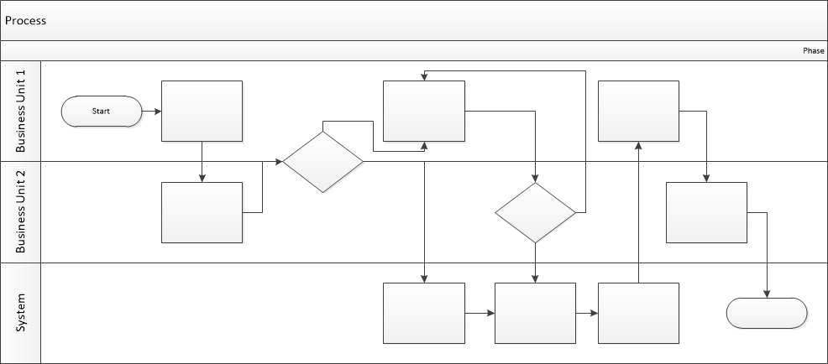

Proposed Business Process (To-Be)
- Technical Lead searches repository
- If widget is not found, user creates a new widget name record.
- WINS validates that all fields have been completed.
- WINS confirms that no similar widgets exist
- User confirms record to be created.

- User searches repository to locate existing widget description.
- WINS displays record
- User selects Edit to open and modify record
- WINS validates all fields completed correctly
- User confirms changes.
- WINS confirms changes and updates Audit table.


Stakeholder Requirements
SR-001: Users need to search hotels by destination, travel dates, and number of guests, including children's ages.
SR-002: Users need fast search results (up to 1-2 seconds)
SR-003: Users need to filter hotels by price, rating, free cancellation, and amenities
SR-004: Users need to view hotel locations on a map
SR-005: Users need accurate real-time hotel availability
SR-006: A business owner needs analytics on unsuccessful filter combinations

The requirements in this document are prioritized as follows:
Value | Rating | Description
1 | Critical | This requirement is critical to the success of the project. The project will not be possible without this requirement.
2 | High | This requirement is high priority, but the project can be implemented at a bare minimum without this requirement.
3 | Medium | This requirement is somewhat important, as it provides some value but the project can proceed without it.
4 | Low | This is a low priority requirement, or a “nice to have” feature, if time and cost allow it.
5 | Future | This requirement is out of scope for this project, and has been included here for a possible future release.

Functional Requirements
Req# | Priority | Description | Rationale | Use Case Reference | Impacted Stakeholders
General / Base Functionality
FR-G-001 | 1 | The system shall allow users to search hotels by destination and to select check-in and check-out dates using a calendar | Enable users to find hotels in the selected location for a specific travel period |  | Users
FR-G-002 | 2 | The system shall provide autocomplete suggestions while users enter a destination | Help users find faster a destination |  | Users
FR-G-003 | 1 | The system shall allow users to specify the number of adults and children, including children's ages | Hotel prices depend on guest composition |  | Users
FR-G-004 | 1 | The system shall allow filtering hotels by price range and by review rating | Help users find hotels within their budget and find highly rated hotels |  | Users
FR-G-005 | 1 | The system shall allow users to filter hotel search results by free cancellation availability | Help users find hotels without sanctions |  | Users
FR-G-006 | 2 | The system shall allow users to filter hotel search results by available amenities, including Wi-Fi, parking, and breakfast | Help users find hotels according to their needs |  | Users
FR-G-007 | 2 | The system shall display hotel search results in both list view and map view and allow users to switch between them | Help users browse hotels in a way that's convenient for them |  | Users
FR-G-008 | 1 | The system shall display recommended hotels based on predefined business rules | Based on margin or affiliate agreements |  | Business Owner
FR-G-009 | 1 | The system shall display marketing labels such as "Only 1 room left" and "Best Price" | Encourage users to complete a booking |  | Business Owner
FR-G-010 | 1 | The system shall synchronize hotel availability with external APIs or a Channel Manager | Ensure accurate room availability |  | Business Owner
FR-G-011 | 2 | The system shall collect and store analytics on filter usage, including filter combinations that return no search results | Will help with data collection |  | Business Owner
Security Requirements
FR-S-001 | 1
Reporting Requirements
FR-R-001 | 2
Usability Requirements
FR-U-001 | 2
Audit Requirements
FR-A-001 | 1

Non-Functional Requirements
[Include technical and operational requirements that are not specific to a function. This typically includes requirements such as processing time, concurrent users, availability, etc.]
ID | Requirement
NFR-001 | The system shall return hotel search results within 2 seconds after the user submits a search request
NFR-002 | The system shall support multiple languages
NFR-003 | The system shall support multiple currencies
NFR-004 | The system shall synchronize hotel availability with external systems and update room status within a few seconds after receiving changes
NFR-005

Appendices

List of Acronyms
[If needed, create a list of acronyms used throughout the BRD document to aid in comprehension.]

Glossary of Terms
[If needed, identify and define any terms that may be unfamiliar to readers, including terms that are unique to the organization, the technology to be employed, or the standards in use.]

Related Documents
[Provide a list of documents or web pages, including links, which are referenced in the BRD.]

